20.11.2018
MECE 441 Control System Design Laboratory

- Given the system of figure below, design an ideal derivative compensator to yield a 16% overshoot, with a threefold reduction in settling time.

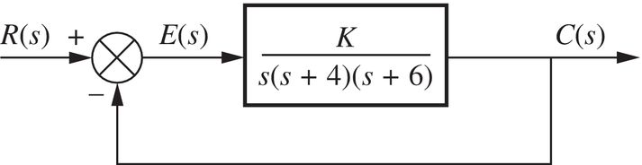
Figure 1 Feedback control system for question1 and question2

Use MATLAB, the Control System Toobox, and the following steps to use SISOTOOL to perform the design.
- Type SISOTOOL in the MATLAB Command Window.
- Select Import in the File menu of the SISO Design for SISO Design Task Window.
- In the Data field for G, type zpk([],[0,-4,-6],1) and hit ENTER on the keyboard.
- On the Edit menu choose SISO Tool Preferences and select Zero/pole/gain: under the Options tab.
- Right-click on the root locus white space and choose Design Requirements/New.
- Choose Percent overshoot and type in 16.
- Right-click on the root locus white space and choose Design Requirements/New.
- Choose Settling time drag the settling time vertical line to the intersection of the root locus and 16% overshoot radial line.
- Read the settling time at the bottom of the window.
- Drag the settling time vertical line to a settling time that is 1/3 of the value found in Step 8.
- Click on a red zero icon in the menu bar. Place the zero on the root locus real axis by clicking again on the real axis.
- Left-click on the real-axis zero and drag it along the real axis until the root locus intersects the settling time and percent overshoot lines.
- Drag a red square along the root locus until it is at the intersection of the root locus, settling time line, and the percent overshoot line.
- Click the Compensator Editor tab of the Control and Estimation Tools Manager window to see the resulting compensator, including the gain.

- Design three lead compensators for the system of Figure 1 that will reduce the settling time by a factor of 2 while maintaining 30% overshoot. Compare the system characteristics between three designs.

