27.11.2018
MECE 441 Control System Design Laboratory

- Given the unity feedback system;

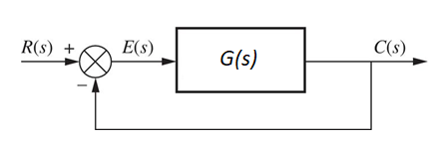 | 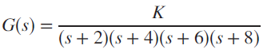

- Find the transfer function of a lag-lead compensator that will;
- yield a settling time 0.5 second shorter than that of the uncompensated system,
- improve the steady-state error by a factor of 30.
The compensated system will have a damping ratio of 0.5. The compensator zero is at -5.
- Find the compensated system’s gain.
- Verify the design through simulation.

- The unity feedback system shown in below;

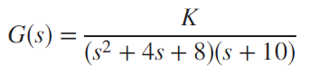

is to be designed to meet the following specifications:
- Overshoot: Less than 22%
- Settling time: Less than 1.6 seconds
- K_{p} = 15
- Evaluate the performance of the uncompensated system operating at approximately 10% overshoot.
- Design a passive compensator to meet the desired specifications.

