18.12.2018
MECE 441 Control System Design Laboratory

- Using the Root Locus design technique, design a PD controller for the system shown in Figure 1 to reduce the settling time by a factor of 4 while continuing to operate the system with 20.5% overshoot. Compare the performance of the compensated system to that of the uncompensated system. Summarize the results in given table. Attach all your work to this table including Matlab files, figures, and calculations.
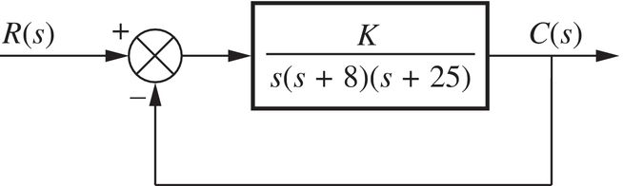
Figure 1
- For the unity feedback system in Figure 2, design a controller using the Root Locus design technique to meet the following requirements.
- Overshoot ≤ 25% and
- Settling Time ≤ 2-second settling time for a step input
- Zero steady-state error for step input.
Summarize the results in given table. Attach all your work to this table including Matlab files, figures, and calculations.
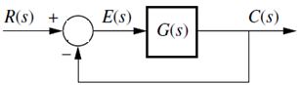  Figure 2 | $$G\left(s\right)=\frac{K}{(s+4)(s+6)(s+10)}$$

