MECE 441 Lab Exercise

- Find the step response of each of the transfer functions shown in below equations and compare them.

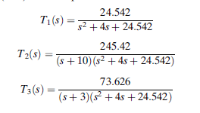
- Open the SIMULINK model “lab_first_order_system.slx”. Find the parameter “a” of the first order system.
  - With the default parameter settings of simulink
  - With the fixed step size of 1e-5
  - With the fixed step size of 1e-6
Comment on the results.

- Open the SIMULINK model “lab_second_order_system.slx”. Find the transfer function of the given system.
  - With the default parameter settings of simulink
  - With the fixed step size of 1e-5.
  - With the fixed step size of 1e-6.
Comment on the results.

- Obtain a linearized model around the equilibrium point (u_{Q}; y_{Q}) = (-2; 0), by using MATLAB function linmod.
