MECE 441 Lab. Exercises

- In Figure 1, let G(s) = 5 and P(s) = 7/(s+2).
  - Calculate the steady-state error due to a command input R(s) = 3/s with D(s) = 0.
  - Verify the result of Part a using Simulink.
  - Calculate the steady-state error due to a disturbance input D(s) = -1/s with R(s) = 0.
  - Verify the result of Part c using Simulink.
  - Calculate the total steady-state error due to command input R(s) = 3/s and a disturbance D(s) = -1/s applied simultaneously.
  - Verify the result of Part e using Simulink.

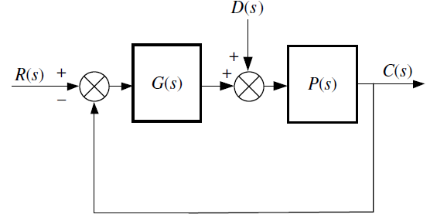
Figure 1: Question-1
- For each of the following closed-loop systems, find the steady-state error for unit step and unit ramp inputs.
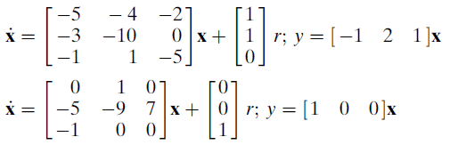

- Given the system shown in Figure 2, find the sensitivity of the steady-state error to parameter a. Assume a step input. Plot the sensitivity as a function of parameter a.

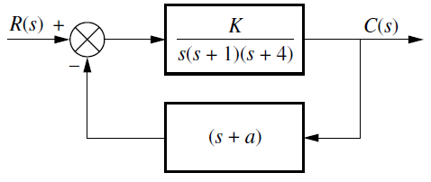
Figure 2: Question 3

