25.12.2018
MECE 441 Control System Design Laboratory

- Consider the following transfer function:
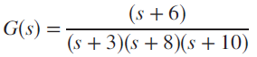
If the system is represented in cascade form, as shown in figure below, design a controller to yield a closed-loop response of 10% overshoot with a settling time of 1 second. Design the controller by first transforming the plant to phase variables.

- The open-loop system of question 1 is represented as shown in figure below. If the output of each block is assigned to be a state variable, design the controller gains for feedback from these state variables.

